Powys War Memorials Project
Presteigne war memorial
Case study
Case

Presteigne war memorial is a stone (granite) cenotaph located just outside the John Beddoes Campus of Newtown High School in Presteigne, Powys. Although the memorial is in a fenced off area, it is still publicly accessible through an unlocked gate.

In total, there are 60 names on the war memorial. Of these, 45 are men, who died during World War 1 and 15 are men, who died during World War 2.

In autumn 2016, Presteigne and Norton Town Council approached the Powys War Memorials Project Officer about the funding for war memorial repair and restoration work.

In October 2016, a local stonemason, the Deputy Mayor of Presteigne and the Town Clerk visited the memorial to record it and to undertake a condition survey. The site visit and survey showed that the memorial needed some work, e.g.

- The memorial needed a complete clean to remove the build-up of moss on the surface and within the hand carved letters.

- The 1250 (approximate) letters on the memorial needed to be re-enamelled due to the moss retaining moisture and lifting the existing enamel.

- There were several joints on the memorial that required re-pointing to prevent water ingress and subsequent freeze-thaw damage.

- The concrete landing surrounding the memorial needed repair work, e.g. cement filling the cracks and re-pointing the joints.

The local stonemason quoted approximately £2100 to undertake all the repair and maintenance work. The Powys War Memorials Project agreed to fund 90% of the total cost (about £1900). Presteigne Town Council agreed to match-fund the outstanding 10%.

Once the match-funding had been agreed and confirmed, the stonemason was commissioned to start work on the war memorial.
The photograph below (April 2017) shows the repair and maintenance work almost finished.
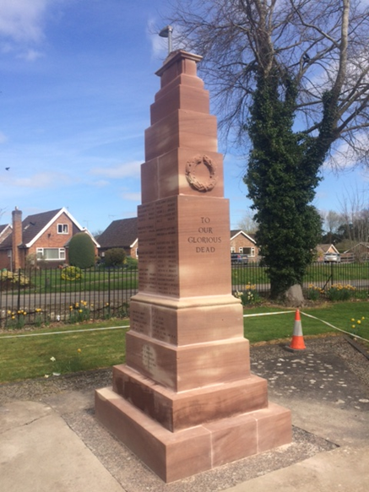
Photograph courtesy of Tracey Price (Town Clerk)

The Mayor of Presteigne, James Tennant-Eyles said:

“The War Memorial is much very valued by the whole community of Presteigne. It holds particular significance in the lives of the many residents, whose family members have been involved in the conflicts for which it stands in remembrance. It is wonderful to see it so beautifully restored and this is a testament to the importance of the lives lost.”
(April 2017)

The Powys War Memorials Project can provide funding of up to £5000 per memorial for repair, restoration or maintenance work. The project can also provide funding of up to £200 for improvements to war memorial settings or surroundings. The application process is straightforward and easy.

Please contact Nathan Davies if you would like to apply for funding for war memorial repair or restoration work:
Nathan Davies (Powys War Memorials Project Officer)
Warmemorials@powys.gov.uk
01597 827 597
www.powyswarmemorials.co.uk

